**Contents:**

**1.** **Origins and Early Celebrations:** 2

**2.** **Medieval and Renaissance Periods:** 3

**3.** **Puritan Influence and Decline in Celebrations** 3

**4.** **The Revival of Christmas in the 19th Century:** 3

**5.** **Conclusion:** 3

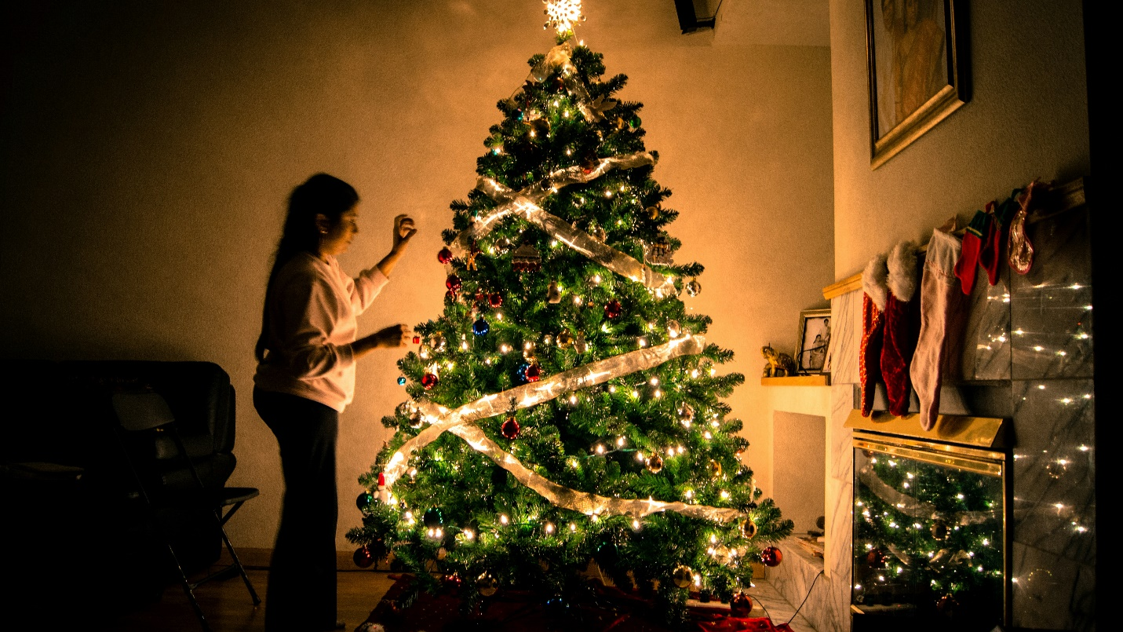

**History Of Christmas Celebration**

Christmas, celebrated on December 25th each year, is one of the most significant holidays in the Christian calendar, marking the birth of Jesus Christ. While it has deep religious roots, the way Christmas is celebrated today has evolved over centuries, blending Christian traditions with cultural customs from around the world.

# **Origins and Early Celebrations:**

The exact date of Jesus' birth is not mentioned in the Bible. The early Christians did not celebrate his birth at all. It wasn't until the 4th century AD that December 25th was officially recognized as the date of Christ's birth by the Roman Church. This date coincided with the Roman pagan festival of Saturnalia, a week-long period of feasting and gift-giving in honor of the god Saturn, as well as the celebration of the winter solstice.By choosing December 25th, early Christians may have aimed to offer an alternative to these popular pagan festivals and help spread Christianity throughout the Roman Empire. Over time, Christian practices merged with local customs, creating a unique blend of religious and secular traditions.

# **Medieval and Renaissance Periods:**

During the Middle Ages, Christmas was marked by elaborate feasts, music, and pageantry. Church services played a central role, and people celebrated with games, plays, and communal meals. In many European countries, the celebration extended over twelve days, from Christmas Day to Epiphany (January 6th), giving rise to the term "The Twelve Days of Christmas."The Renaissance period saw the rise of caroling, where people would sing festive songs from house to house, spreading cheer throughout communities.

# **Puritan Influence and Decline in Celebrations:**

In the 17th century, Puritan influence in England and New England led to a decline in Christmas celebrations. The Puritans viewed the holiday as too closely tied to pagan rituals and banned festivities altogether. In fact, Christmas was outlawed in parts of colonial America, and those who celebrated it could face fines.

# **The Revival of Christmas in the 19th Century:**

Christmas experienced a revival in the 19th century, thanks in part to several influential works. Charles Dickens’ A Christmas Carol (1843) helped reshape the holiday as a time for family, generosity, and goodwill. The poem “A Visit from St. Nicholas” (commonly known as ’Twas the Night Before Christmas), published in 1823, popularized many modern Christmas traditions, including Santa Claus and the hanging of stockings.Queen Victoria and Prince Albert also played a role in popularizing the Christmas tree in England and beyond, after illustrations of their decorated tree were published in the 1840s.

# **Conclusion:**

Christmas continues to bring people from diverse backgrounds together in celebration and reflection. Christmas has grown to encompass values of faith, family, generosity, and joy. Whether observed for its spiritual significance or embraced as a time of togetherness and festivity.